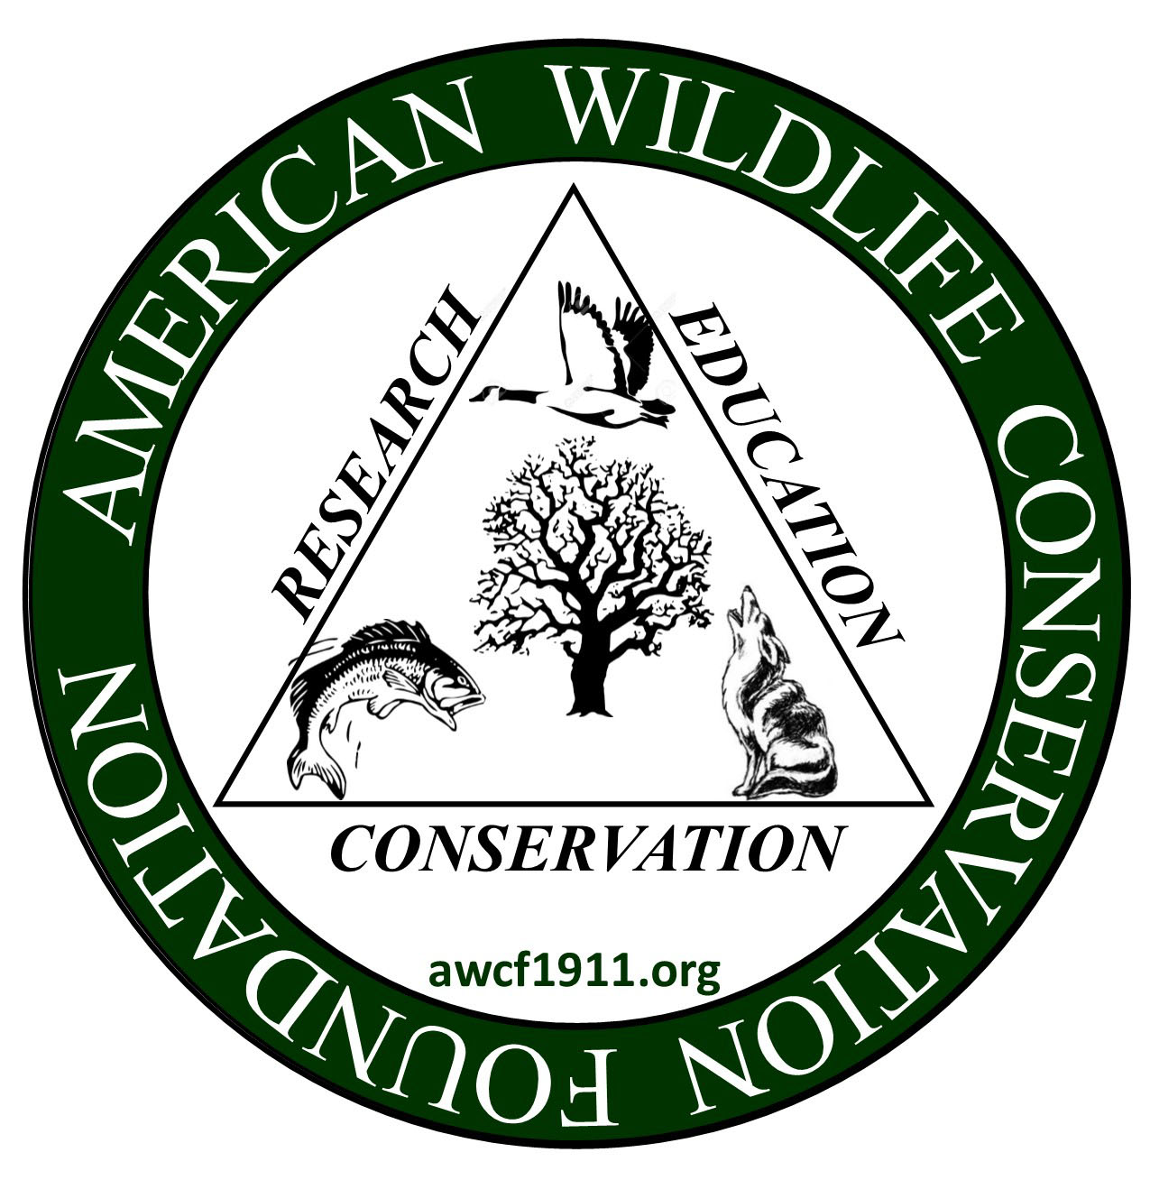
American Wildlife Conservation Foundation, Inc.
William C. Churchill Fund - Karl T. Fredrick Memorial Fund
CONSERVATION - EDUCATION - RESEARCH

Grant Request Form – Page 1

Robert F. Gotie, Chair, Grants Committee
Email: rgotie@twcny.rr.com

The American Wildlife Conservation Foundation is a multi-national foundation operating throughout the United States, Canada and Mexico. As such, grants are only available for proposals applied to the North American Continent. The Foundation’s mission is to aid in discovery, understanding and dissemination of information that supports scientific fish and wildlife management through research, education and habitat conservation. The AWCF is a small Foundation and we select only five or six proposals each year. We allocate between $2,000 and $6,000 for individual proposals selected for funding, so competition is intense.
Funding priority is given to proposals from universities, government agencies and other non-profit institutions/organizations which focus on fish/wildlife species-habitat relationships, human-wildlife interaction or conservation education projects.
Grant money shall only be used for: direct stipend to the field researcher, supplies, reasonable equipment, travel and lodging, if directly related to the research. We do not allow overhead or indirect costs to be charged by the sponsoring institution nor do we allow funds to partially pay for the salary of a supervisor or oversight staff.
The application must be submitted electronically in an MS Word format to the current Grants Committee Chair (as noted at the top of this form). You may down-load this form from the website, save it as a word document, compose your proposal under each heading and email to the Grants Chair. The signature page can be signed, electronically scanned and then inserted within your MS Word document. Please note. The application deadline has been changed to February 1st of each year beginning in 2022.

Title of Proposal:
How does food quality for insectivorous songbirds vary among native and non-native plants in Connecticut forests?

Type of Project:
Ecological research project quantifying the nutritional quality of insect prey for migratory songbirds on invasive shrubs and native plants

Name, Title, PO address and email address of Principal Investigator:
Robert Clark, Research Scientist
New Fairfield CT 06812
rclark@greathollow.org

Name and complete address of the Institution/Agency/Organization:
Great Hollow Nature Preserve & Ecological Research Center
225 State Route 37
New Fairfield CT 06812

Name, Title, and email address of Institution/Agency/Organization Representative:
Chad Seewagen, Executive Director
cseewagen@greathollow.org

Project Duration: Start Date and End Date: April 30 to Dec 23 2022

Amount Requested: $1000.00

American Wildlife Conservation Foundation, Inc.
William C. Churchill Fund - Karl T. Fredrick Memorial Fund
CONSERVATION - EDUCATION - RESEARCH

Grant Request Form – Page 2

Project Plan

Objectives: The spread of invasive species is among the most devasting impacts humans can have on the environment. Invasive species are particularly abundant in disturbed environments in proximity to high human population density. In fragmented forests this especially true, where invasive shrubs can dominate forest understories. Non-native plants displace native shrubs, removing important food sources for wildlife that originally depended on those native plant species. Effective forest habitat management prioritizes removal of monocultures of invasive plants in an attempt to reestablish the resources available to wildlife, especially migratory songbirds. However, in Connecticut forests, there are hundreds of invasive plant species that have become widespread. A handful of these species are particularly abundant, including Japanese Barberry, Asiatic honeysuckles, Burning bush, and Autumn olive. The outlined project will focus on these four focal species and compare them to native understory trees and samplings common in many Northeastern US forests: Striped maple, Witch-hazel, American beech (saplings), Black birch (saplings), Musclewood, and Shadbush. By quantifying the food quantity and food quality, we can provide recommendations on which understory invasive shrubs are the ‘worst offenders’ of these four, and also reveal which common native species provide superior food availability to birds in place of exotic species. This information will focus management efforts, helping to improve the food availability for our migratory songbirds.

Location of the project: In this project we are quantifying the abundance of arthropod prey available to birds and attempting to assess the difference in nutritional quality (protein content) between native and non-native understory wood plants at Great Hollow Nature Preserve (New Fairfield, CT).

Methods to be used: In 2021 we did a bird exclusion experiment to compare which arthropods were taken from native and non-native shrubs by songbirds. Surprisingly, some invasive shrubs like honeysuckle have equivalent biomass of arthropods and insectivorous birds remove prey at similar rates compared to natives. However, some non-native plants, like barberry, have fewer insect prey available and experience apparently lower foraging effort by insectivorous birds. The next step in this project is to quantify the protein) content of the arthropod prey we collected from native and non-native shrubs.

Anticipated benefits to AWCF Mission and Focus: We will determine the ‘worst offenders’ in terms of insectivorous bird food provided by invasive plants. This information will allow land managers to target their resources for invasive plant control towards the worst species and have the greatest conservation impact for birds in managed forests. Deliverables include:
- The first ranked list of food quality for ten species of native and non-native shrubs for insectivorous birds (for Connecticut forests and other regions that have been invaded by these plant species)
- Publication on the degree to which forest songbirds forage for insect prey on native vs. non-native plants.
- Information for the general public on what native understory trees (of the six studied) provide the highest quality ‘bird food’
- Recommendations for management of non-native plants, including a priority list due to poor food availability and/or quality for insectivorous wildlife.

Time schedule for this project: Fieldwork has been completed, this proposal provides funding for the nutritional analysis to quantify indirect food quality of native and invasive plants for songbirds.

- Summer 2021: Field surveys of insects and bird exclusion experiment (Completed in August)
- Preparation of samples to be sent for C/N Ratio analysis (Jan 2022)
- Isotope analysis of samples at Cornell University (April 2022)
- Statistical modeling of bird exclusion effects on native and non-native plants (March 2022)
- Data on nutritional quality among host plants use in scientific manuscript (May 2022)
- Sept 1 2022: Progress report submitted
- December 23 2022: Final report submitted

Financial Information

Itemize total project costs and include a line item for the AWCF funds:
Protein Content Assay
C:N Ratio Analysis (Arthropods) $8/sample
x 120 trees
$960
Lab consumables $40
Total costs $1000

Describe how the AWCF funds will be used: All funds will be used exclusively to pay for laboratory analyses of nitrogen content (indicator of food quality) using the paid isotopic analysis processing lab at Cornell University.

Other sources (if any) for this project:
All other components of this project (labor, fieldwork materials, data analysis) has been supported by Great Hollow Nature Preserve & Ecological Research Center.

All publications resulting from this project will acknowledge the support of the AWCF, Inc. One copy of such publications will be sent electronically in MS Word format to the Foundation at AWCF1911. A progress report shall be submitted to the Foundation by September 1 of each year during the project’s duration. At the conclusion of the project, a brief summary (≤two page) of the final report and at least one appropriate picture or diagram will be submitted to the Foundation. Both progress and final reports shall be sent to the Grants Chair in electronic MS Word format.
If this grant is accepted, it is strongly encouraged that either/both the Principal Investigator and the Agency Representative become contributing members of the American Wildlife Conservation Foundation.

Required Signatures:

Robert Clark Research Scientist 1/13/2022
(Signature of Applicant) (Title of Applicant) (Date of Application)
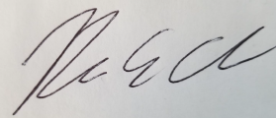
_____________________________

_________________________________ ___________________________ ____________________________
(Signature of Agency Representative) (Title of Agency Representative) (Date of Application)

_______________________________
(Printed Name of Agency Representative)

